**Individual Paragraph**

I want to focus on developing the instructor dashboard and reporting features, as they are central to improving students' learning experience and providing valuable insights into assignment outcomes and overall class performance. This feature excites me because it enables instructors to visualize student progress and leverage AI-generated feedback to better understand both individual and class-wide strengths and areas for improvement. Additionally, I’m interested in designing a user-friendly interface allowing instructors to easily configure chatbots, set specific AI-assistance parameters, and create task delineated assignments.

**Individual Activities**

**Apply the C-K Theory**

1. Concepts:
   1. Task delineated Assignment Builder
   2. Instructor performance dashboard
   3. User friendly interface
2. There are component libraries and frameworks that can be used to efficiently develop these concepts for the web UI.
   1. Component libraries such as ShadCN have a variety of accessible and customizable components that can be used to quickly build out the assignment builder and performance dashboards while keeping a user-friendly interface.
   2. We can utilize frontend frameworks such as React to create reusable components to reduce development time.
3. By leveraging component libraries like ShadCN and frontend frameworks like React, we can efficiently develop a user-friendly tool that features a task-delineated assignment builder and instructor performance dashboard, making complex assignments clear for students and providing actionable insights for instructors.

**Domain Model**

Task delineated assignment builder

* Entities: Instructor, Course, Assignment, Task, PerformanceReport
* Relationships:
  + Instructors have multiple courses
  + Courses have multiple assignments
  + Assignments have multiple tasks
  + Assignments have a performance report

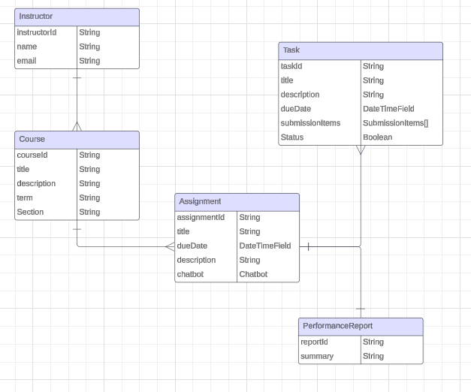

**Weekly Work Intensity**

| **Week** | **Predicted Effort** | **Actual Effort** | **Other Commitments** |
| --- | --- | --- | --- |
| 0 | Low | Low | Interviews |
| 1 | Low | Low | Interviews |
| 2 | Medium | Low | CS450 Project |
| 3 | Medium | Low | Interviews, CS450 Project |
| 4 | Low | Low | CS450 Project |
| 5 | High | Low | CS450 Midterm |
| 6 | Low | Medium | Interviews, CS450 Project |
| 7 | Medium |  | CS450 Project |
| 8 | Medium |  |  |
| 9 | N/A |  | CS450 Project |
| 10 | Low |  | CS372, CS450 Final |

During week 6, I put in a medium amount of effort working on the requirements document. I plan to continue having medium/high effort throughout the following weeks as well.